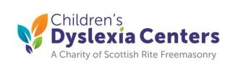

Fund Raiser for the Verdon R. Skipper Children’s Dyslexic Center
When: SUNDAY, March 22, 2026 - 1:00PM to 4:00PM
Where: TOPGOLF - 104 Centerton Rd., Mt. Laurel. NJ (856) 793-4084
Cost: $80.00 PER PERSON
What’s Included: 3 Hours of Video Golf game fun, 6 people per Hitting Bay.
SMOKEHOUSE BBQ for 1-1/2 hours including soft drinks.
Golf clubs and golf balls included. BYO clubs if desired.
TOPGOLF Ambassadors present for instruction and assistance.
Facility is temperature controlled and all Hitting Bays are under cover and heated!
Adult beverages available for purchase.
Do You need to be good at golf to have fun?
Absolutely not! With holes the size of craters, anyone at any age or ability level can play and enjoy. Team Play makes the day even more fun. All experience levels will have a terrific time!
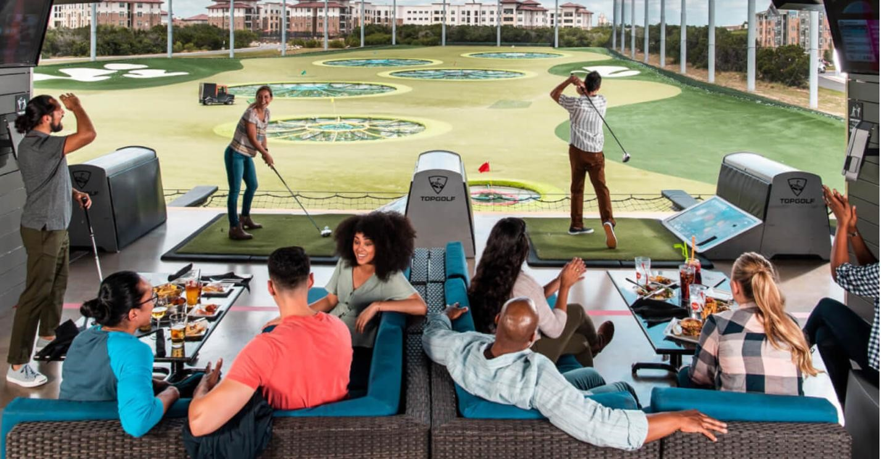
The price of Golf Participation for this CDC event is $80.00 per golfer.
Everyone of ALL ages are Welcome. Register solo, with your Significant Other or with a group.
Only 6 participants per Hitting Bay.
Clubs are provided but bring your own clubs, golf glove and shoes if desired.
TOPGOLF HAS NO ACCOMODATIONS FOR SPECTATORS BECAUSE OF SPACE RESTRICTIONS
** IMPORTANT – Make Your Reservations by Monday, March 16th**
Name: ____________________________________ Phone _________________________ Email Address: _____________________________________________________________
Additional Players in Your Group - Up To 6 Names per Hitting Bay.
If registering over 6 players, please list those names on back of the form.
- __________________________________ Email _____________________________
- __________________________________ Email _____________________________
- __________________________________ Email _____________________________
- __________________________________ Email _____________________________
- __________________________________ Email _________________________
Children’s Dyslexia Center SPONSORSHIPS AVAILABLE:
Platinum - $525 - Includes all the amenities for 6 golfers plus signage for the event.
Gold - $285 - Includes all the amenities for 3 golfers plus signage for the event.
Silver - $205- Includes all the amenities for 2 golfers plus signage at the event. HITTING BAY SPONSOR - $75.00 for a sign at the Buffet
Please send Checks payable to: Verdon R. Skipper Dyslexia Center
Mail Registrations and Checks to: John Bradshaw, 14 Medoc Court, Marlton NJ 08053
Questions: John Bradshaw, poppyjohn@comcast.net , Phone 609-694-6272 V.2022.02.14b

